Through-hole subtraction

Definition
# Source: AI Source: Provided by: [Data Path: Persons Table -> ID Column: 1, Name_En Column: Motasem Essam] -> From: [ChatGPT] on [7/25/2026]
Through-Hole Subtraction is a method of forming a modified solid by removing material through an opening that passes completely from one surface of the original solid to another opposite or otherwise accessible surface.
The removed region creates a continuous passage through the entire solid. The opening may have a circular, rectangular, triangular, polygonal, or other cross-sectional shape.
Unlike a blind-hole subtraction, a through-hole extends completely through the original solid.
Simple Definition: Through-hole subtraction is the process of removing material from a solid to create a hole that passes completely through it.

Geometric Representation
# Source: AI Source: Provided by: [Data Path: Persons Table -> ID Column: 1, Name_En Column: Motasem Essam] -> From: [ChatGPT] on [7/25/2026]
A through-hole can be created by removing a smaller solid-shaped region from a larger solid.
Common examples include:
- A cylindrical hole passing through a rectangular prism.
- A rectangular opening passing through a cube.
- A triangular hole passing through a prism.
- A polygonal opening passing through a solid.
- Multiple holes passing through the same solid.
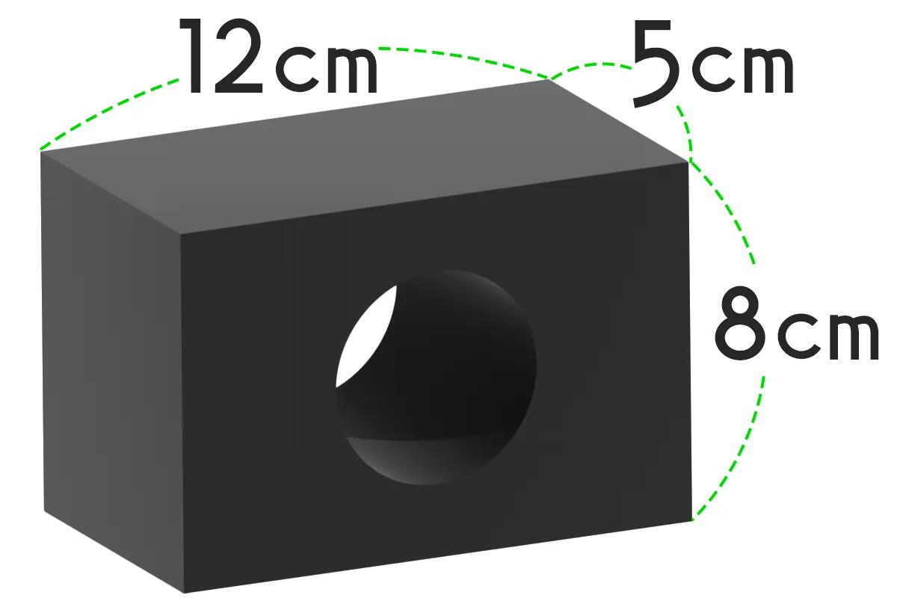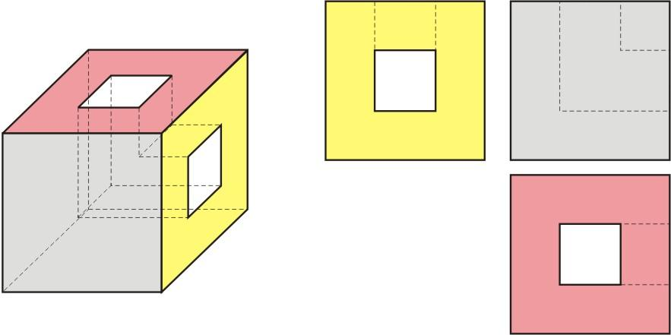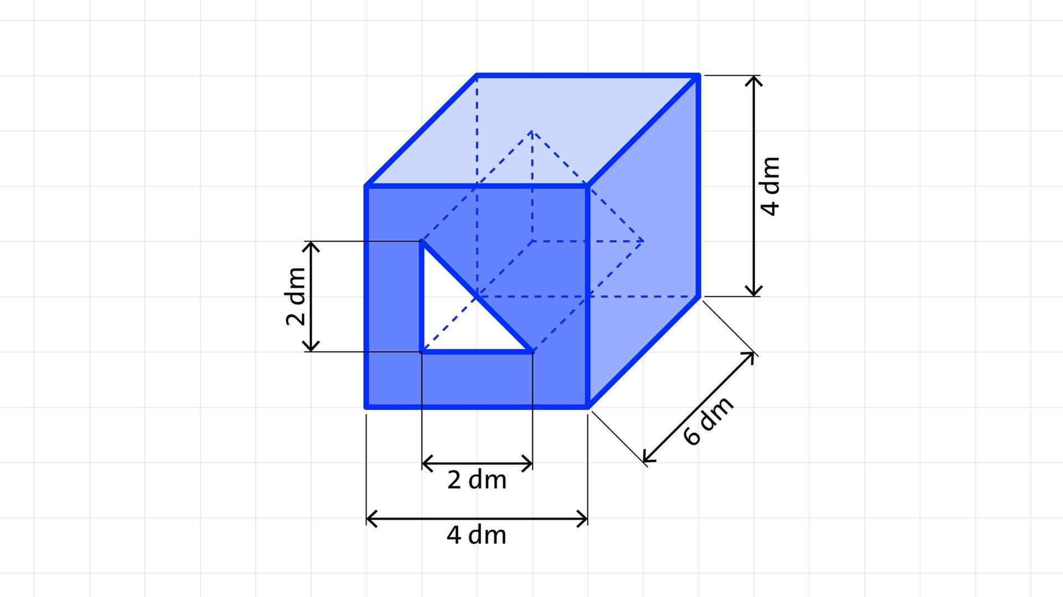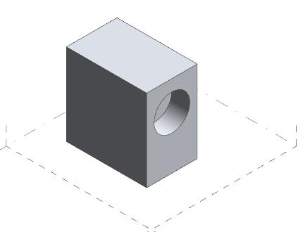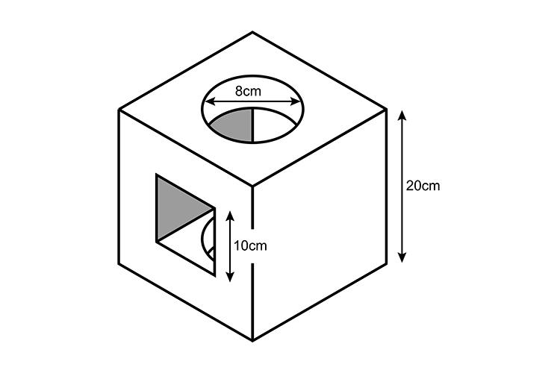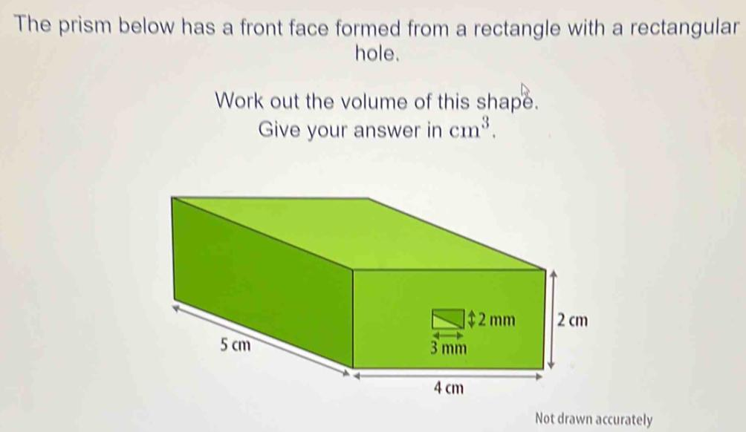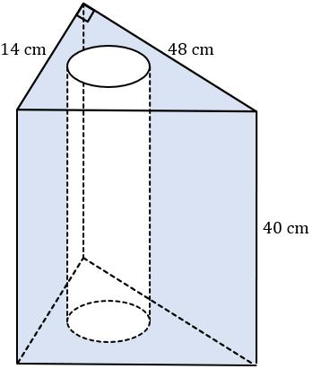

Main Classification

Types of Through-Hole Subtraction
# Source: AI Source: Provided by: [Data Path: Persons Table -> ID Column: 1, Name_En Column: Motasem Essam] -> From: [ChatGPT] on [7/25/2026]

Cylindrical Through-Hole Subtraction
# Source: AI Source: Provided by: [Data Path: Persons Table -> ID Column: 1, Name_En Column: Motasem Essam] -> From: [ChatGPT] on [7/25/2026]
Material is removed using a cylindrical region that passes completely through the original solid.
Examples:
- Circular hole through a rectangular prism.
- Cylindrical hole through a cube.
- Multiple parallel cylindrical holes through a solid.
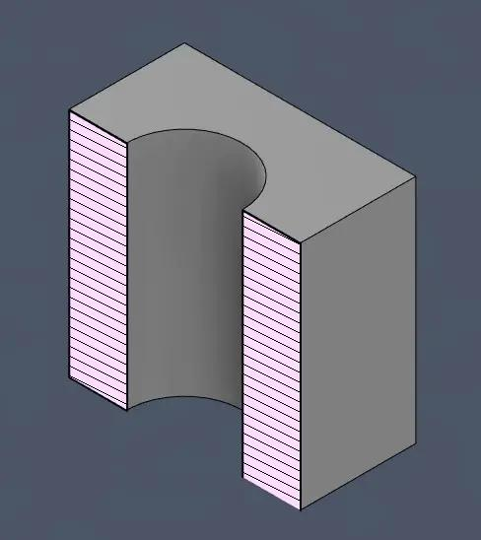

Rectangular Through-Hole Subtraction
# Source: AI Source: Provided by: [Data Path: Persons Table -> ID Column: 1, Name_En Column: Motasem Essam] -> From: [ChatGPT] on [7/25/2026]
Material is removed using a rectangular prism-shaped region that passes completely through the original solid.
Examples:
- Rectangular opening through a cube.
- Long rectangular passage through a rectangular prism.
- Multiple rectangular passages through a solid.
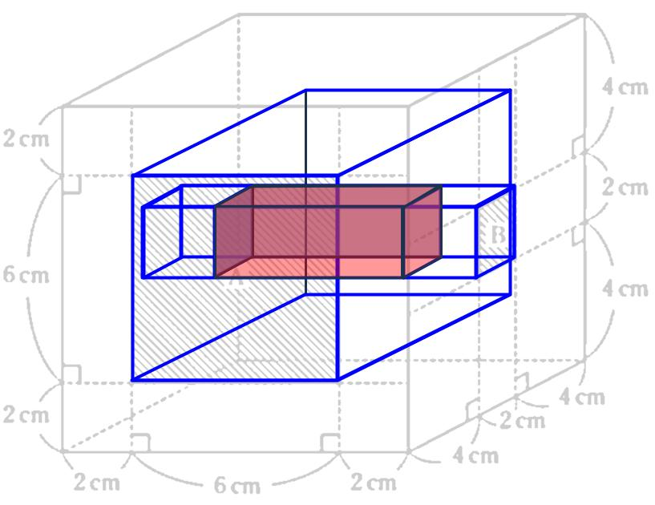

Square Through-Hole Subtraction
# Source: AI Source: Provided by: [Data Path: Persons Table -> ID Column: 1, Name_En Column: Motasem Essam] -> From: [ChatGPT] on [7/25/2026]
Material is removed using a square-prism-shaped region that passes completely through the original solid.
Examples:
- Square hole through a cube.
- Square tunnel through a rectangular prism.
- Multiple square openings through a solid.
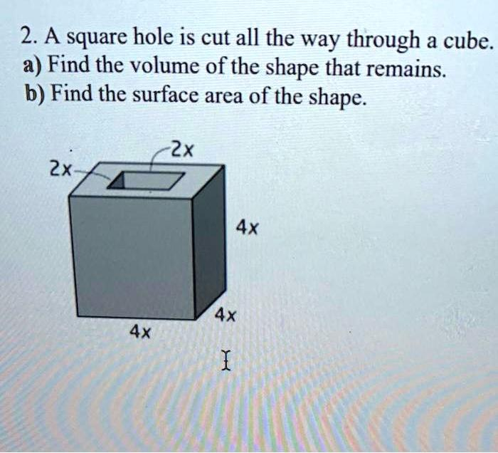

Triangular Through-Hole Subtraction
# Source: AI Source: Provided by: [Data Path: Persons Table -> ID Column: 1, Name_En Column: Motasem Essam] -> From: [ChatGPT] on [7/25/2026]
Material is removed using a triangular-prism-shaped region that passes completely through the original solid.
Examples:
- Triangular opening through a rectangular prism.
- Triangular tunnel through a cube.
- Multiple triangular passages through a solid.

Polygonal Through-Hole Subtraction
# Source: AI Source: Provided by: [Data Path: Persons Table -> ID Column: 1, Name_En Column: Motasem Essam] -> From: [ChatGPT] on [7/25/2026]
Material is removed using a prism-shaped region with a polygonal cross-section.
Examples:
- Pentagonal through-hole.
- Hexagonal through-hole.
- Octagonal through-hole.
- Other regular or irregular polygonal openings.
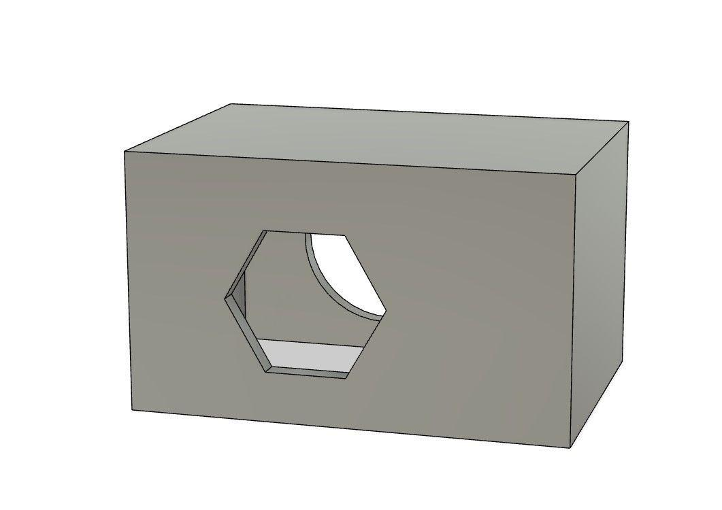

Conical Through-Hole Subtraction
# Source: AI Source: Provided by: [Data Path: Persons Table -> ID Column: 1, Name_En Column: Motasem Essam] -> From: [ChatGPT] on [7/25/2026]
Material is removed using a conical region that passes completely through the original solid.
The opening may have a changing cross-sectional size along its depth.
Examples:
- Tapered conical passage through a block.
- Conical opening through a thick plate.
- Opposing conical cuts forming a double-tapered passage.
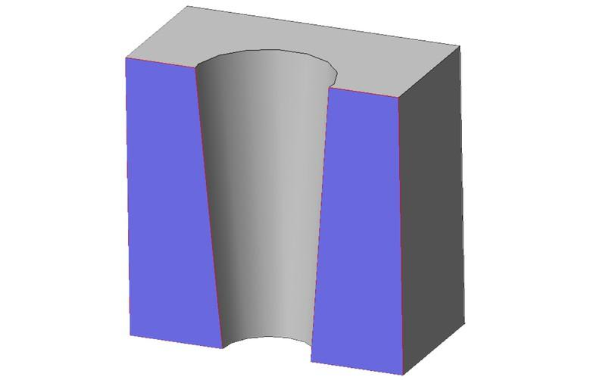

Stepped Through-Hole Subtraction
# Source: AI Source: Provided by: [Data Path: Persons Table -> ID Column: 1, Name_En Column: Motasem Essam] -> From: [ChatGPT] on [7/25/2026]
Material is removed using two or more connected hole sections with different cross-sectional dimensions.
Examples:
- Large cylindrical opening connected to a smaller cylindrical opening.
- Counterbored through-hole.
- Stepped rectangular passage.
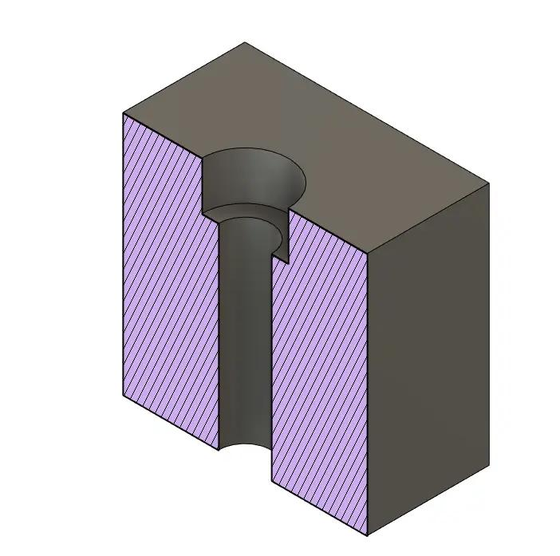

Mixed-Shape Through-Hole Subtraction
# Source: AI Source: Provided by: [Data Path: Persons Table -> ID Column: 1, Name_En Column: Motasem Essam] -> From: [ChatGPT] on [7/25/2026]
Material is removed using a passage that contains two or more different cross-sectional shapes.
Examples:
- Circular opening connected to a rectangular passage.
- Cylindrical opening combined with a conical section.
- Polygonal entrance connected to a cylindrical tunnel.
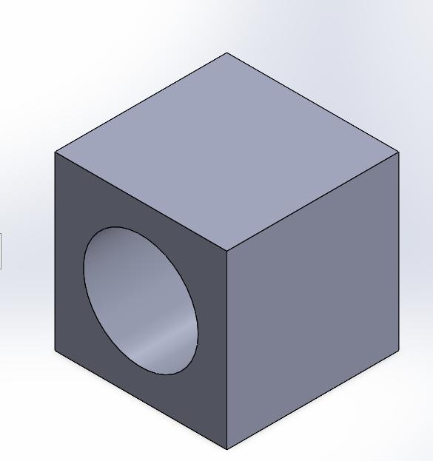

Classification by Hole Direction
# Source: AI Source: Provided by: [Data Path: Persons Table -> ID Column: 1, Name_En Column: Motasem Essam] -> From: [ChatGPT] on [7/25/2026]
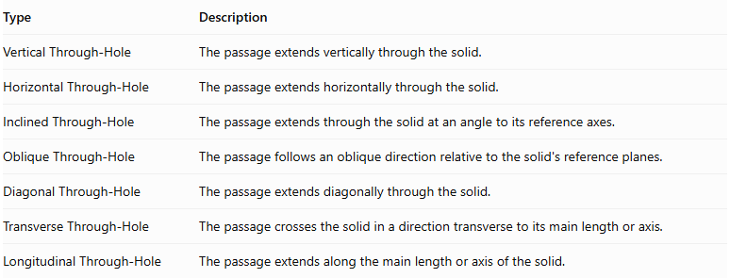
Type | Description
Vertical Through-Hole | The passage extends vertically through the solid.
Horizontal Through-Hole | The passage extends horizontally through the solid.
Inclined Through-Hole | The passage extends through the solid at an angle to its reference axes.
Oblique Through-Hole | The passage follows an oblique direction relative to the solid's reference planes.
Diagonal Through-Hole | The passage extends diagonally through the solid.
Transverse Through-Hole | The passage crosses the solid in a direction transverse to its main length or axis.
Longitudinal Through-Hole | The passage extends along the main length or axis of the solid.
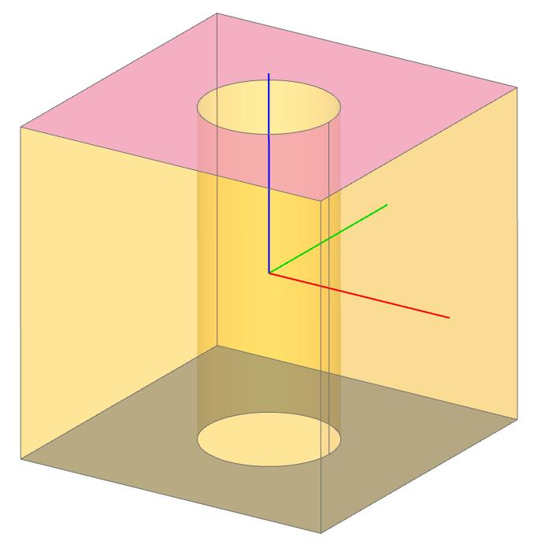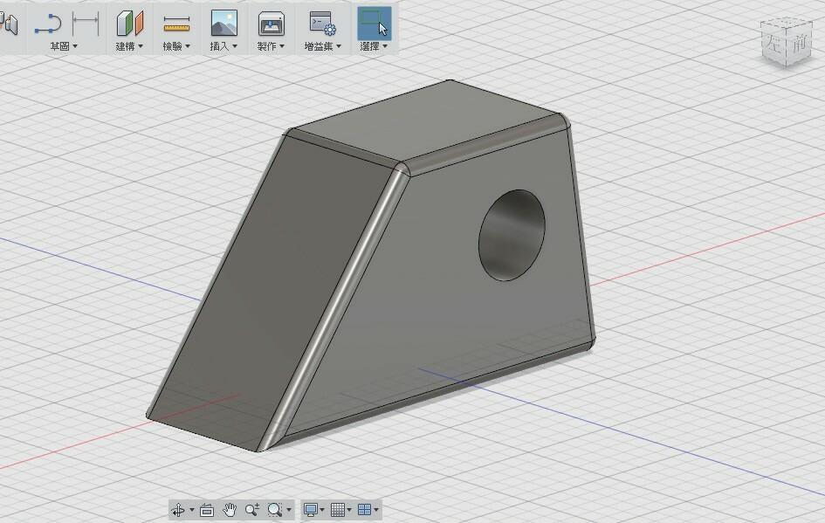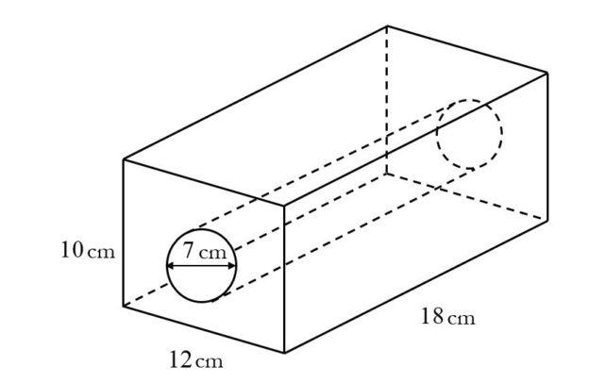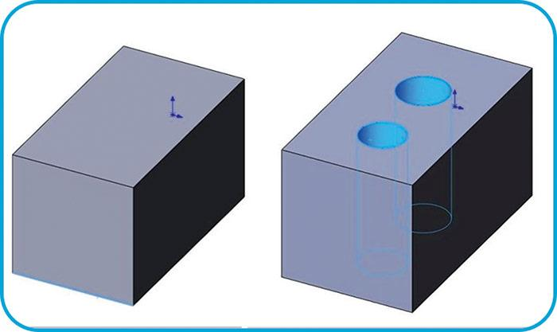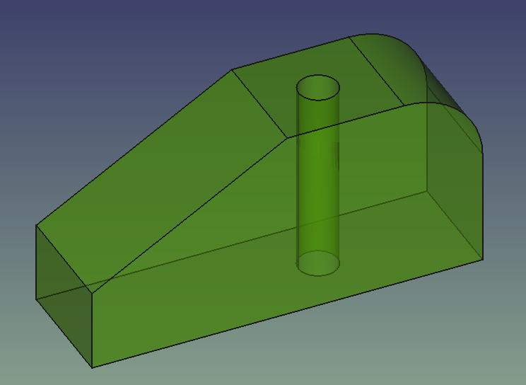

Classification by Number of Holes
# Source: AI Source: Provided by: [Data Path: Persons Table -> ID Column: 1, Name_En Column: Motasem Essam] -> From: [ChatGPT] on [7/25/2026]
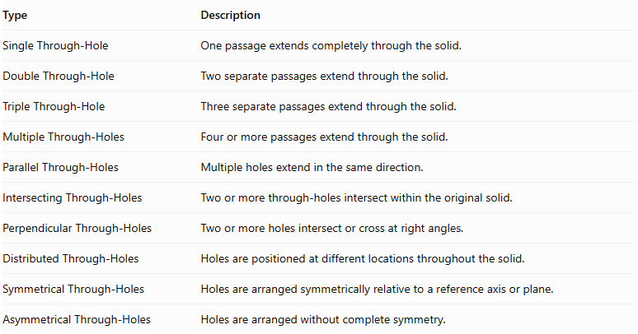
Type | Description
Single Through-Hole | One passage extends completely through the solid.
Double Through-Hole | Two separate passages extend through the solid.
Triple Through-Hole | Three separate passages extend through the solid.
Multiple Through-Holes | Four or more passages extend through the solid.
Parallel Through-Holes | Multiple holes extend in the same direction.
Intersecting Through-Holes | Two or more through-holes intersect within the original solid.
Perpendicular Through-Holes | Two or more holes intersect or cross at right angles.
Distributed Through-Holes | Holes are positioned at different locations throughout the solid.
Symmetrical Through-Holes | Holes are arranged symmetrically relative to a reference axis or plane.
Asymmetrical Through-Holes | Holes are arranged without complete symmetry.
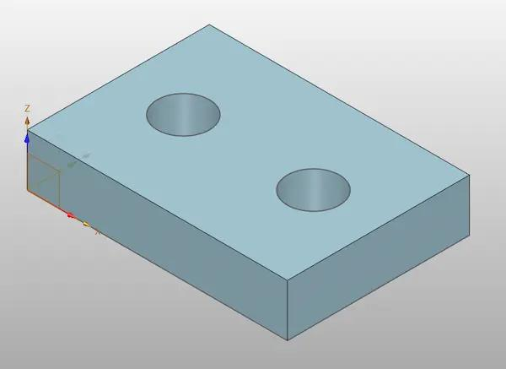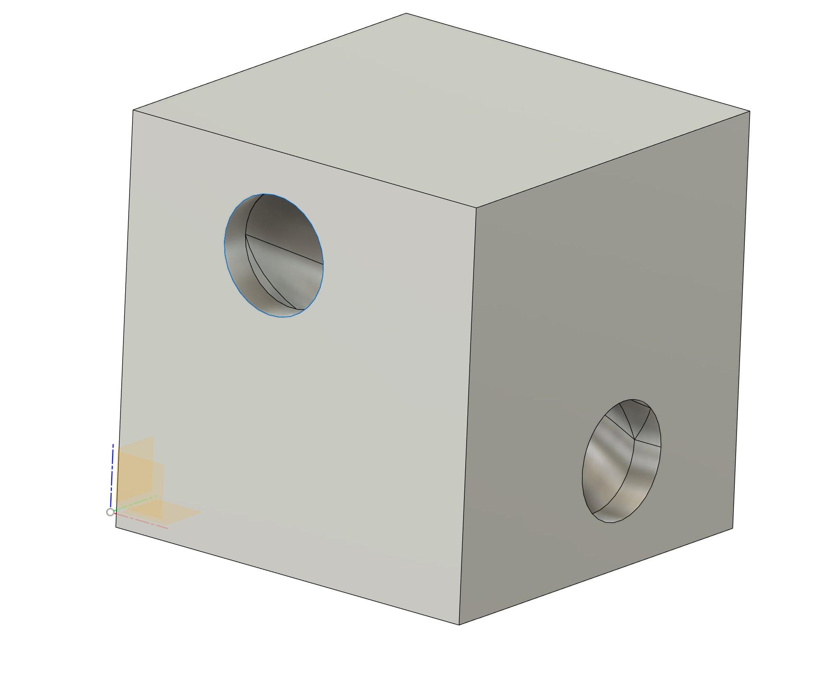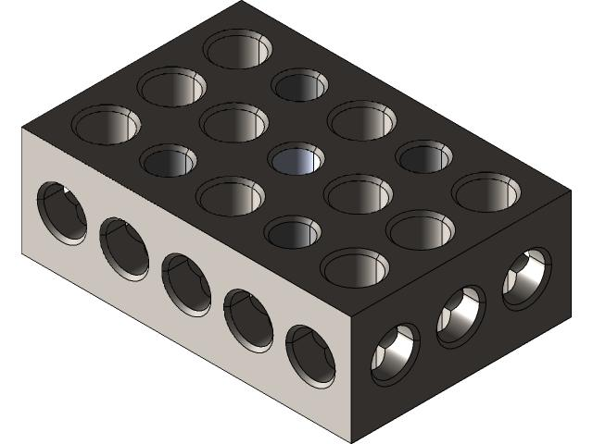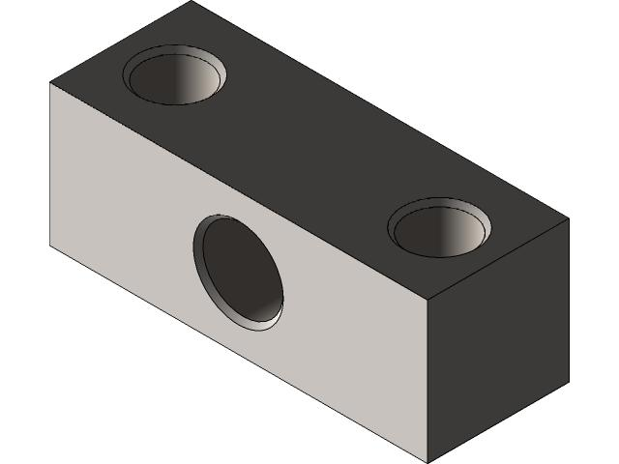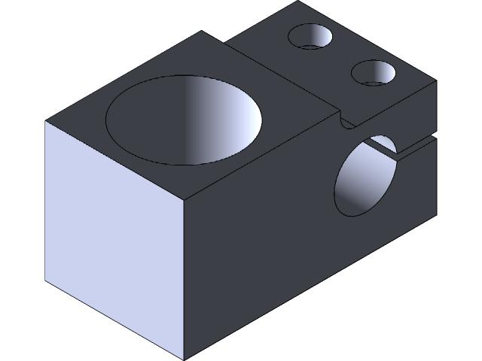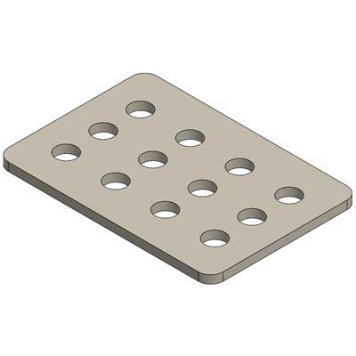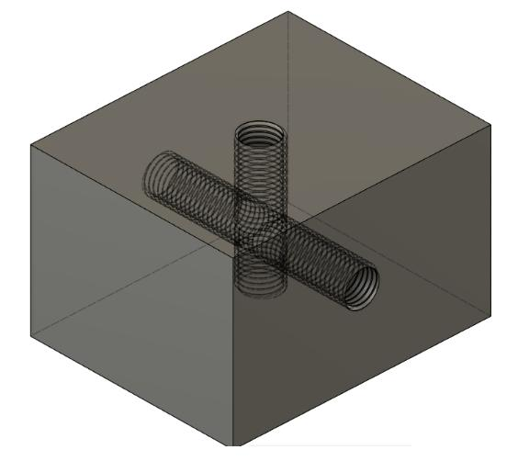

Classification by Cross-Sectional Shape
# Source: AI Source: Provided by: [Data Path: Persons Table -> ID Column: 1, Name_En Column: Motasem Essam] -> From: [ChatGPT] on [7/25/2026]
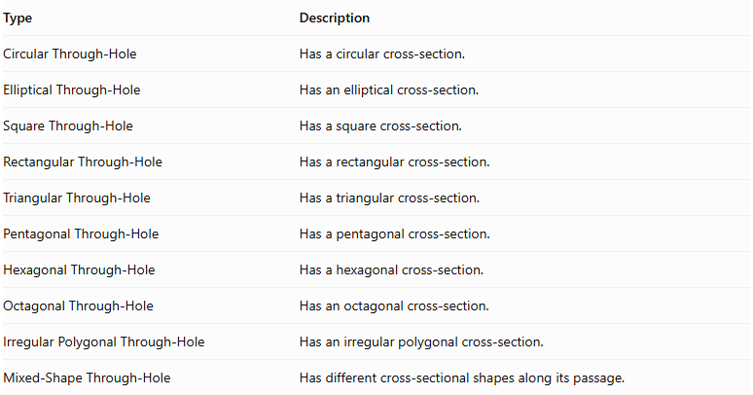
Type | Description
Circular Through-Hole | Has a circular cross-section.
Elliptical Through-Hole | Has an elliptical cross-section.
Square Through-Hole | Has a square cross-section.
Rectangular Through-Hole | Has a rectangular cross-section.
Triangular Through-Hole | Has a triangular cross-section.
Pentagonal Through-Hole | Has a pentagonal cross-section.
Hexagonal Through-Hole | Has a hexagonal cross-section.
Octagonal Through-Hole | Has an octagonal cross-section.
Irregular Polygonal Through-Hole | Has an irregular polygonal cross-section.
Mixed-Shape Through-Hole | Has different cross-sectional shapes along its passage.

Mathematical Properties and Formulas
# Source: AI Source: Provided by: [Data Path: Persons Table -> ID Column: 1, Name_En Column: Motasem Essam] -> From: [ChatGPT] on [7/25/2026]
The volume and surface area depend on the shape of the original solid and the geometry of the removed passage.

Volume
# Source: AI Source: Provided by: [Data Path: Persons Table -> ID Column: 1, Name_En Column: Motasem Essam] -> From: [ChatGPT] on [7/25/2026]
The remaining volume is calculated by subtracting the removed volume from the original solid's volume.
$$V_{remaining}=V_{original}-V_{hole}$$
For multiple non-overlapping holes:
$$V_{remaining}=V_{original}-\sum_{i=1}^{n}{V_{{hole}_{i}}}$$
If the removed regions overlap, their intersection volumes must be handled to avoid subtracting the same region more than once.

Cylindrical Through-Hole
# Source: AI Source: Provided by: [Data Path: Persons Table -> ID Column: 1, Name_En Column: Motasem Essam] -> From: [ChatGPT] on [7/25/2026]
For a cylindrical hole:
$$V_{hole}=πr^{2}h$$
Where:
- $r$ = Radius of the hole.
- $h$ = Length of the passage through the solid.
Therefore:
$$V_{remaining}=V_{original}-πr^{2}h$$

Rectangular Through-Hole
# Source: AI Source: Provided by: [Data Path: Persons Table -> ID Column: 1, Name_En Column: Motasem Essam] -> From: [ChatGPT] on [7/25/2026]
For a rectangular-prism-shaped passage:
$$V_{hole}=lwh$$
Where:
- $l$ = Length of the passage.
- $w$ = Width of the opening.
- $h$ = Height of the opening.

Conical Through-Hole
# Source: AI Source: Provided by: [Data Path: Persons Table -> ID Column: 1, Name_En Column: Motasem Essam] -> From: [ChatGPT] on [7/25/2026]
For a complete conical region removed from a solid:
$$V_{hole}=\frac{1}{3}πr^{2}h$$
For a conical frustum passage:
$$V_{hole}=\frac{1}{3}πh(R^{2}+Rr+r^{2})$$
Where $R$ and $r$ are the larger and smaller radii.

Surface Area
# Source: AI Source: Provided by: [Data Path: Persons Table -> ID Column: 1, Name_En Column: Motasem Essam] -> From: [ChatGPT] on [7/25/2026]
Through-hole subtraction changes the original external surface area because it:
- Removes the original surface regions covered by the openings.
- Creates new internal lateral surfaces along the passage.
- May create additional surfaces when the passage is stepped or tapered.
For a cylindrical through-hole passing perpendicularly through a rectangular prism:
$${SA}_{remaining}={SA}_{original}-2πr^{2}+2πrh$$
This formula assumes the cylindrical opening has two circular entrances, the passage runs straight through the solid, and the opening does not intersect an edge or another hole.
Where:
- $2πr^{2}$ = Area of the two removed circular openings.
- $2πrh$ = Newly exposed internal curved surface area.

Worked Examples

Example 1: Cylindrical Through-Hole in a Rectangular Prism
# Source: AI Source: Provided by: [Data Path: Persons Table -> ID Column: 1, Name_En Column: Motasem Essam] -> From: [ChatGPT] on [7/25/2026]
A cylindrical hole passes vertically through a rectangular prism.
The dimensions are:
- Length = 10 cm
- Width = 8 cm
- Height = 6 cm
- Hole radius = 2 cm
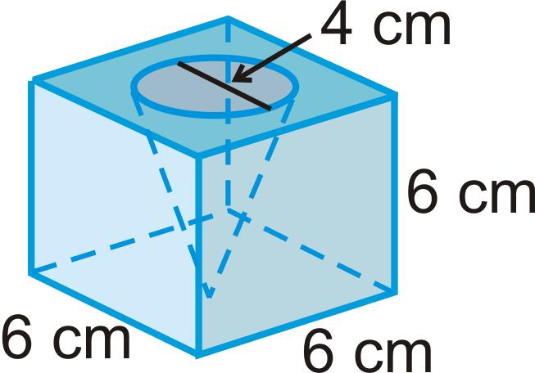
Step 1: Calculate the original volume.
$$V_{original}=lwh$$
$$V_{original}=10×8×6$$
$$V_{original}=480{ cm}^{3}$$
Step 2: Calculate the removed cylindrical volume.
$$V_{hole}=πr^{2}h$$
$$V_{hole}=π(2)^{2}(6)$$
$$V_{hole}=24π$$
Step 3: Calculate the remaining volume.
$$V_{remaining}=480-24π$$
$$\boxed{V_{remaining}≈404.60{ cm}^{3}}$$
Step 4: Calculate the original surface area.
$${SA}_{original}=2(lw+lh+wh)$$
$${SA}_{original}=2(80+60+48)$$
$${SA}_{original}=376{ cm}^{2}$$
Step 5: Calculate the remaining surface area.
The two circular openings are removed, and the internal curved surface of the hole is added.
$${SA}_{remaining}=376-2π(2)^{2}+2π(2)(6)$$
$${SA}_{remaining}=376-8π+24π$$
$$\boxed{{SA}_{remaining}≈426.27{ cm}^{2}}$$

Example 2: Rectangular Through-Hole in a Cube
# Source: AI Source: Provided by: [Data Path: Persons Table -> ID Column: 1, Name_En Column: Motasem Essam] -> From: [ChatGPT] on [7/25/2026]
A rectangular passage extends completely through a cube.
The dimensions are:
- Cube side length = 10 cm
- Passage width = 3 cm
- Passage height = 4 cm
- Passage length = 10 cm
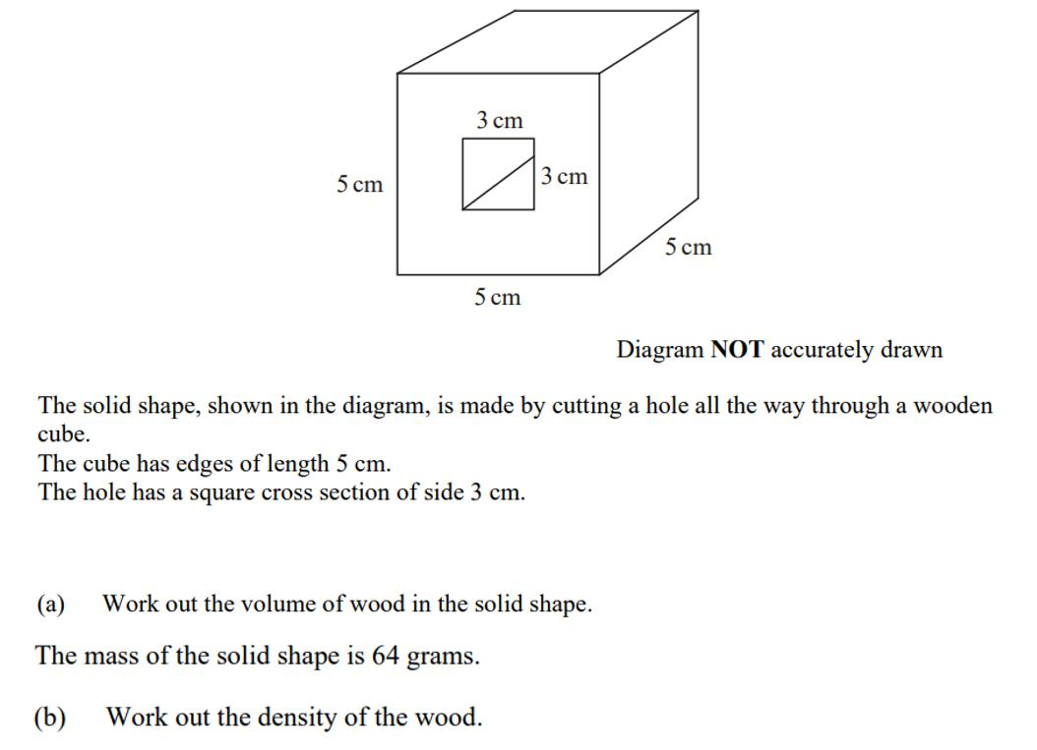
Step 1: Calculate the original cube volume.
$$V_{original}=a^{3}$$
$$V_{original}={10}^{3}=1000{ cm}^{3}$$
Step 2: Calculate the removed volume.
$$V_{hole}=lwh$$
$$V_{hole}=10×3×4$$
$$V_{hole}=120{ cm}^{3}$$
Step 3: Calculate the remaining volume.
$$V_{remaining}=1000-120$$
$$\boxed{V_{remaining}=880{ cm}^{3}}$$
Step 4: Calculate the original surface area.
$${SA}_{original}=6a^{2}$$
$${SA}_{original}=6(10)^{2}$$
$${SA}_{original}=600{ cm}^{2}$$
Step 5: Calculate the remaining surface area.
The two rectangular openings are removed from opposite faces.
$$A_{removed}=2(3×4)=24$$
The internal passage surfaces consist of four rectangular faces:
$$A_{internal}=2(10×3)+2(10×4)$$
$$A_{internal}=60+80=140$$
Therefore:
$${SA}_{remaining}=600-24+140$$
$$\boxed{{SA}_{remaining}=716{ cm}^{2}}$$

Important Characteristics
# Source: AI Source: Provided by: [Data Path: Persons Table -> ID Column: 1, Name_En Column: Motasem Essam] -> From: [ChatGPT] on [7/25/2026]
- The removed passage extends completely through the original solid.
- The opening has at least two entrances or exits at the boundary of the solid.
- The passage can be straight, inclined, or otherwise shaped.
- The cross-section may be circular, rectangular, triangular, polygonal, or mixed.
- The passage may have a constant or changing cross-section.
- Multiple through-holes can exist in the same solid.
- The remaining volume equals the original volume minus the removed volume, with overlap corrections when necessary.
- New internal surfaces are created along the walls of the passage.
- The original external surface area changes according to the size and position of the openings.

Comparison with Other Subtraction Methods
# Source: AI Source: Provided by: [Data Path: Persons Table -> ID Column: 1, Name_En Column: Motasem Essam] -> From: [ChatGPT] on [7/25/2026]
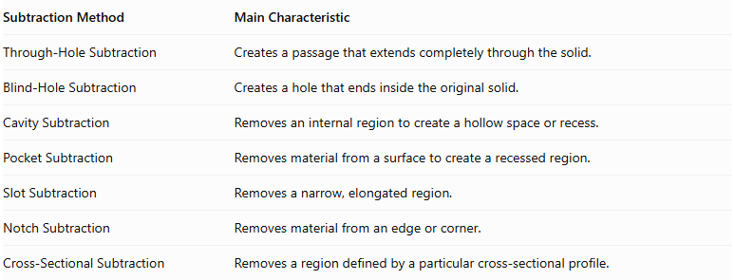
Subtraction Method | Main Characteristic
Through-Hole Subtraction | Creates a passage that extends completely through the solid.
Blind-Hole Subtraction | Creates a hole that ends inside the original solid.
Cavity Subtraction | Removes an internal region to create a hollow space or recess.
Pocket Subtraction | Removes material from a surface to create a recessed region.
Slot Subtraction | Removes a narrow, elongated region.
Notch Subtraction | Removes material from an edge or corner.
Cross-Sectional Subtraction | Removes a region defined by a particular cross-sectional profile.
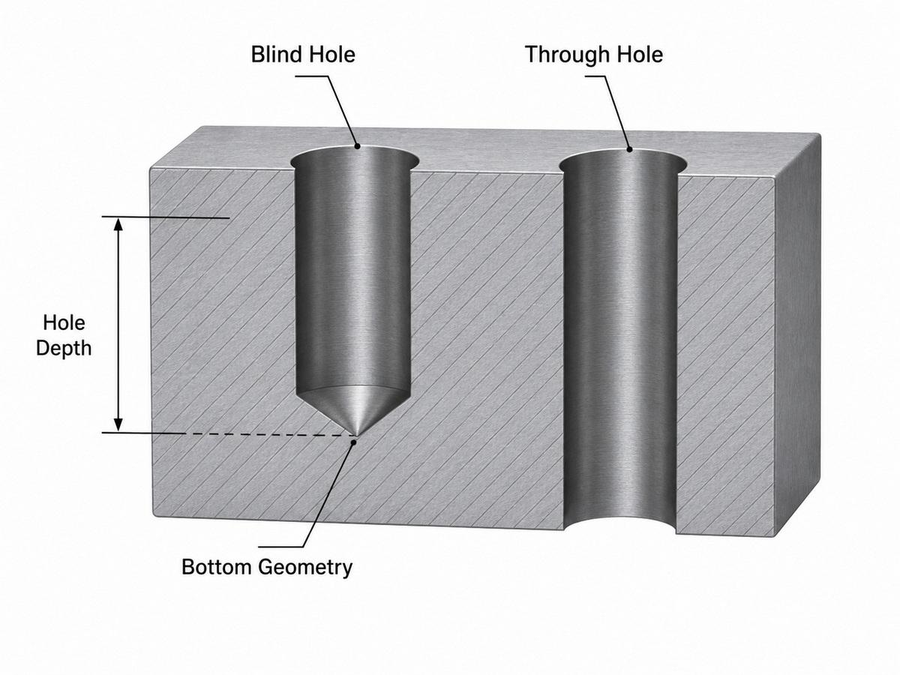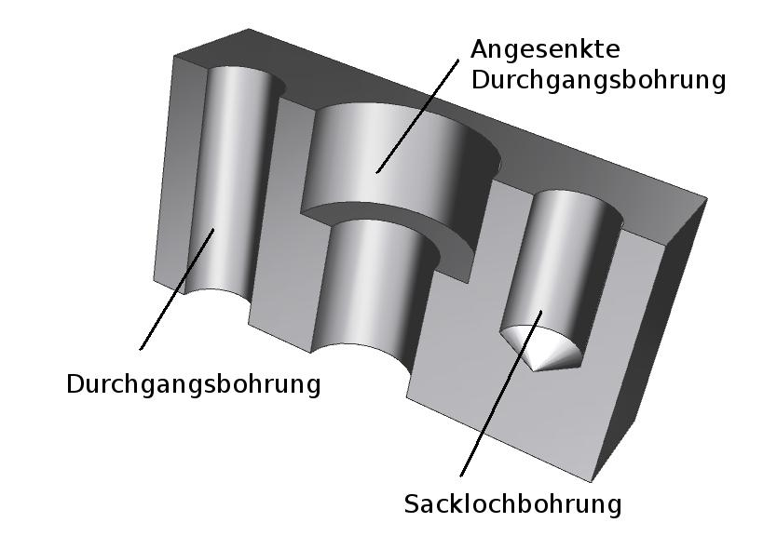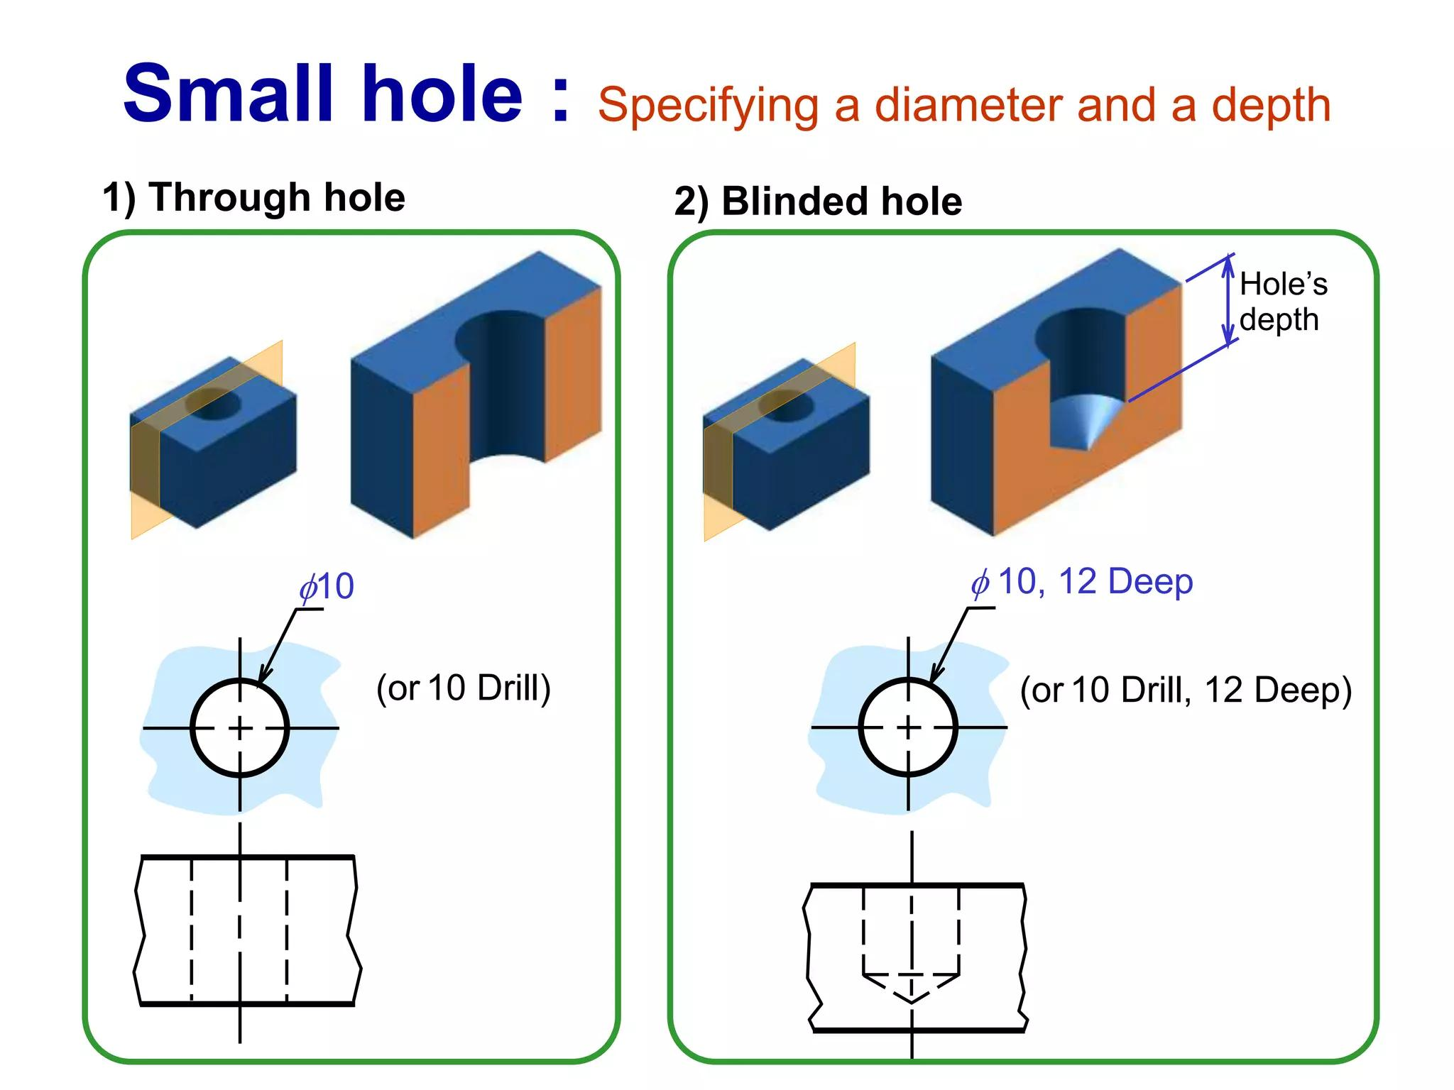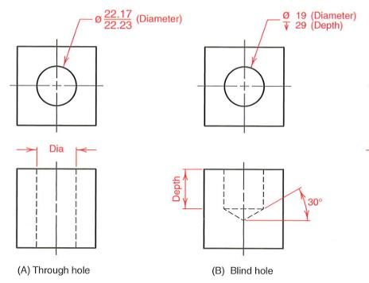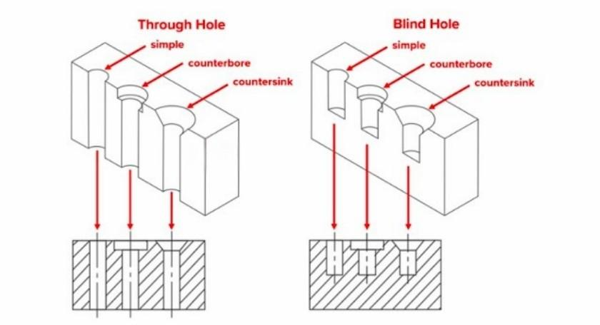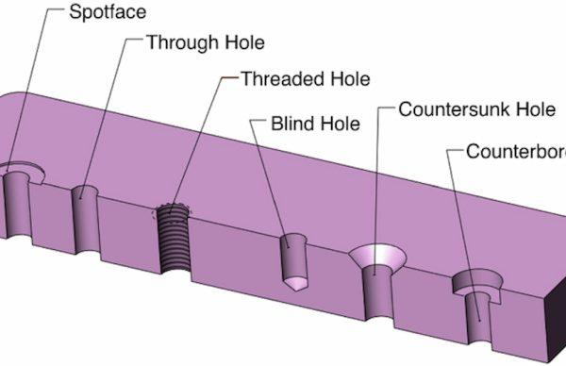

Applications
# Source: AI Source: Provided by: [Data Path: Persons Table -> ID Column: 1, Name_En Column: Motasem Essam] -> From: [ChatGPT] on [7/25/2026]
Through-hole subtraction is commonly used in:
- Mechanical engineering and manufacturing.
- Bolted and screwed connections.
- Pipe and fluid passage systems.
- Ventilation openings.
- Structural components.
- Machine housings.
- Automotive components.
- Electrical cable passages.
- Three-dimensional CAD modeling and machining.

Key Points
# Source: AI Source: Provided by: [Data Path: Persons Table -> ID Column: 1, Name_En Column: Motasem Essam] -> From: [ChatGPT] on [7/25/2026]
- Through-hole subtraction removes material completely through an original solid.
- The opening has an entrance and an exit.
- Through-holes can have circular, rectangular, triangular, polygonal, or mixed cross-sections.
- They can be vertical, horizontal, inclined, or diagonal.
- Multiple holes may be parallel, intersecting, or distributed.
- The remaining volume is the original volume minus the removed volume, with overlap corrections when needed.
- Surface-area calculations must account for removed openings and newly exposed internal passage walls.

Conclusion
# Source: AI Source: Provided by: [Data Path: Persons Table -> ID Column: 1, Name_En Column: Motasem Essam] -> From: [ChatGPT] on [7/25/2026]
Through-Hole Subtraction is a solid-modification method in which material is removed to create a continuous passage extending completely through an original three-dimensional object. The passage may have different cross-sectional shapes, directions, dimensions, and configurations. It may also consist of multiple or stepped openings. This method is important in solid geometry, engineering design, and manufacturing because it provides a systematic way to calculate the remaining volume and external surface area of perforated solids.

